**DAILY ONLINE ACTIVITIES SUMMARY**

|  |  |  |  |  |  |  |  |  |
| --- | --- | --- | --- | --- | --- | --- | --- | --- |
| **Date:** | **21-6-2020** | | | | | **Name:** | **Prajna** | |
| **Sem & Sec** | **8th sem ‘B’** | | | | | **USN:** | **4AL16CS067** | |
| **Online Test Summary** | | | | | | | | |
| **Subject** | | **-** | | | | | | |
| **Max. Marks** | | **-** | | **Score** | | | **-** | |
| **Certification Course Summary** | | | | | | | | |
| **Course** | **Introduction to python programming** | | | | | | | |
| **Certificate Provider** | | | **Great learning** | | **Duration** | | | **2hrs** |
| **Coding Challenges** | | | | | | | | |
| **Problem Statement:**1**.** Write a c program to compare two strings. | | | | | | | | |
| **Status: Completed** | | | | | | | | |
| **Uploaded the report in GitHub**  **GitHub link:** | | | | | **Yes**  **https://github.com/alvas-education-foundation/prajna_k** | | | |
| **If yes Repository name** | | | | | **prajna_k** | | | |
| **Uploaded the report in slack** | | | | | **yes** | | | |

Online Test Details: (Attach the snapshot and briefly write the report for the same)

Certification Course Details: (Attach the snapshot and briefly write the report for the same)

Coding Challenges Details: (Attach the snapshot and briefly write the report for the same)

2) certification course

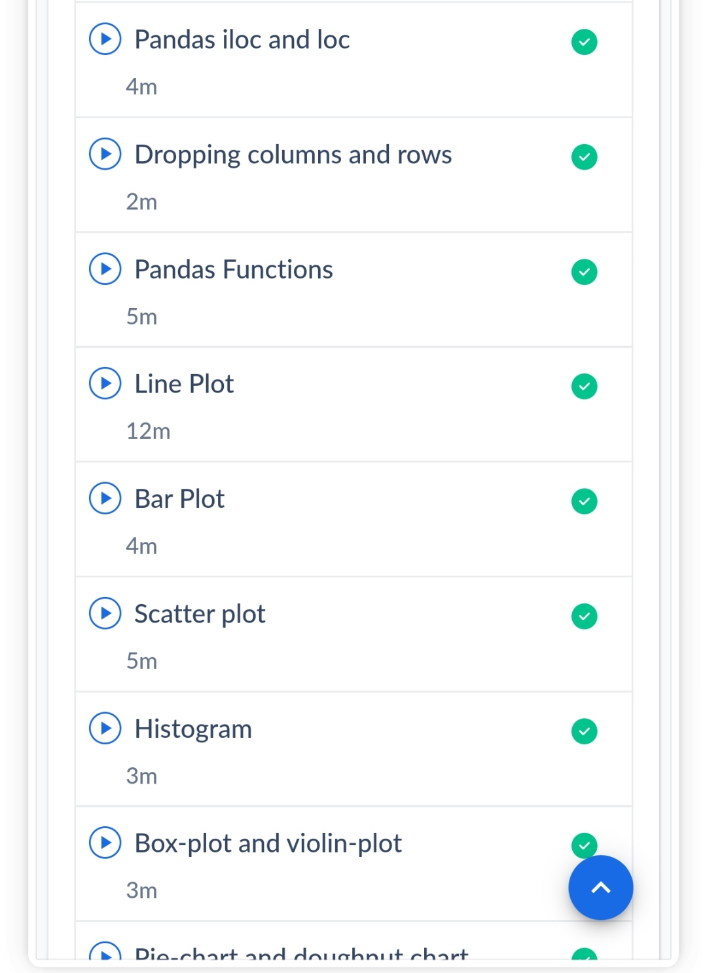

3) coding challenges

#include <stdio.h>

#include <string.h>

#include <stdlib.h>

#define str_size 100

void main()

{

char str1[str_size], str2[str_size];

int flg=0;

printf("\n\nCompare two string whether they are equal or not :\n");

printf("------------------------------------------------------\n");

printf("Input the 1st string : ");

fgets(str1, sizeof str1, stdin);

printf("Input the 2nd string : ");

fgets(str2, sizeof str2, stdin);

int i=0;

while(str1[i] == str2[i])

{

if(str1[i] == '\0' || str2[i] == '\0')

break;

i++;

}

if(str1[i-1] == '\0' && str2[i-1]=='\0')

flg=0;

else if(str1[i] > str2[i])

flg=1;

else if(str1[i] < str2[i])

flg=-1;

if(flg == 0)

{

printf("\nThe length of both strings are equal and \nalso both strings are equal.\n\n");

}

else if(flg == -1)

{

printf("\nThe length of the first string is smaller than second.\n\n");

}

else

{

printf("\nThe length of the first string is greater than second.\n\n");

}

}

|  |
| --- |
|  |
|  |  |
|  |  |
|  |  |
|  |  |
|  |  |